
Frequently Asked Questions
https://www.toms-foodmarkets.com


Sign Up or Log In
Pick Your Products
Choose Your Pickup Time
Come to Tom’sXpressLane
Drive Home Happy!

Click to Navigate to a Topic
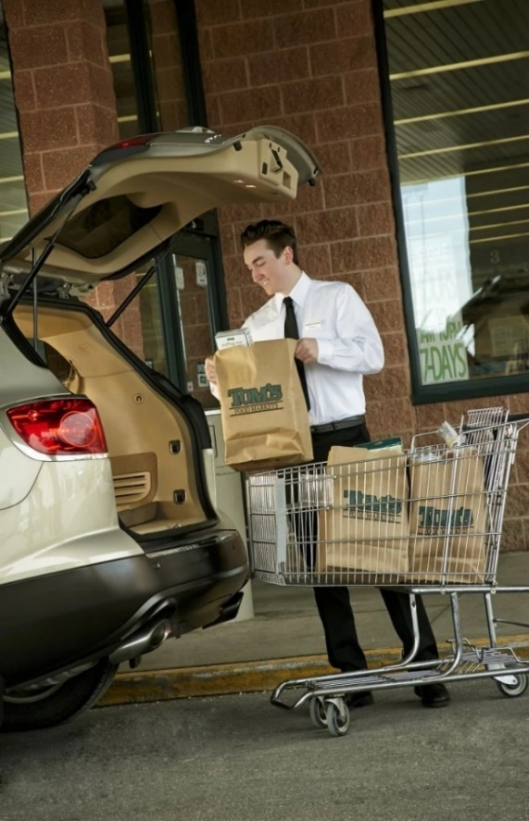
Sign Up Or Log In 2
Creating an Account 2
Which Stores have Tom’sXpress? 2
Pick Your Products 3
Browsing The Shop Menu 3
Get Deals Straight from the Weekly Ad 3
Fresh Items – Ripeness and Weight 4
What if the Product I Order Isn’t Available? 4
Complete Your Order 5
Choose Your Pickup Time 5
Checking Out 5
Come to Tom’sXpress Lane 6
Where to Go 6

Sign Up Or Log In

Creating an Account
Open your internet browser and navigate to https://www.toms-foodmarkets.com
Click on ‘Create an Account’, you’ll be asked to enter basic personal and contact info
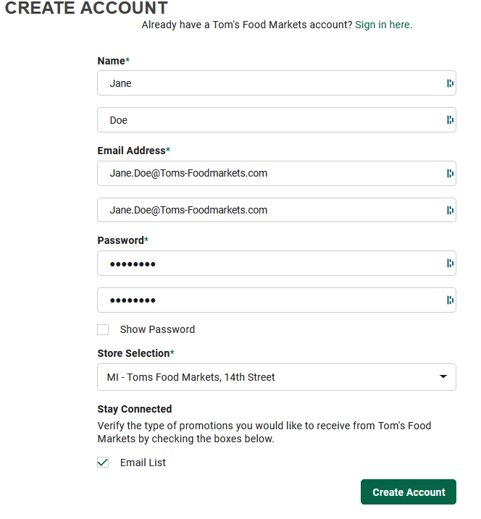
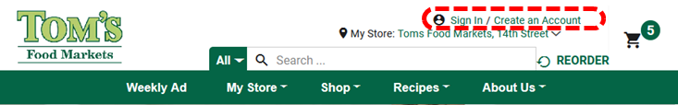

Please use your full name

Email addresses must match

This will be your default store, you can change it at any time

Tell us if you’d like to hear about Tom’s weekly deals!

Which Stores have Tom’sXpress?
We’re launching our first at our 14th Street location (1201 S. Division St in TC), watch our social media channels to see what locations might launch next!


www.instagram.com/tomsfoodmarkets
www.facebook.com/TomsFoodMarkets

Pick Your Products
There are multiple ways to shop: the Shop menu, directly from our weekly ad, directly from recipes, you can even re-order a previous order if you usually get the same items each visit.

Browsing The Shop Menu
Click on ‘Shop’ from the menu bar to go to the Shop page
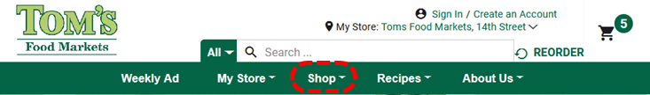
When you arrive at this page, you will see featured items in boxes with Add buttons. Click the Add button next to the items you want to select it, choose your quantity, close the pop-up box and continue shopping.
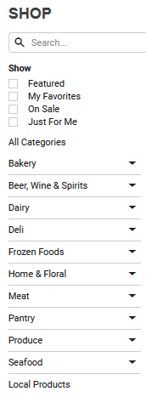
You can also shop via the Shopping sidebar, as well.

Search for items by name here

Filter your search results to find just the right items

Look for your items by department, like walking the aisle at a store

Find Tom’s Local Choice items online!

Get Deals Straight from the Weekly Ad
Click on Weekly Ad from the menu bar to see Tom’s weekly circulars.
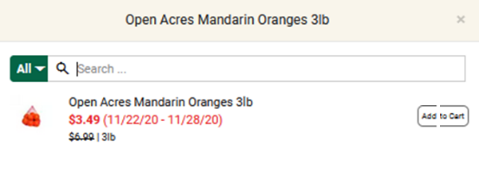
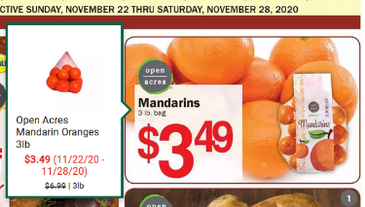
Click an item Add it to your cart

When you click on Add next to the item you want, you will get a numerical selection in order to change the quantity.
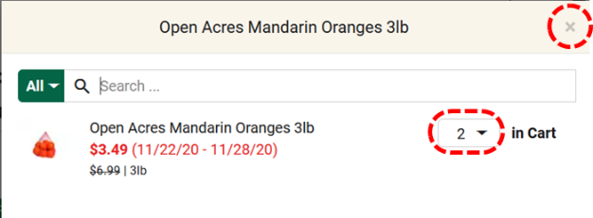
Click the X to continue shopping after choosing quantity

Choose your desired quantity from the dropdown menu

Fresh Items – Ripeness and Weight
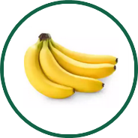
Get your fresh produce just the way you like it! You’ll find additional options when adding a fresh item to your cart.

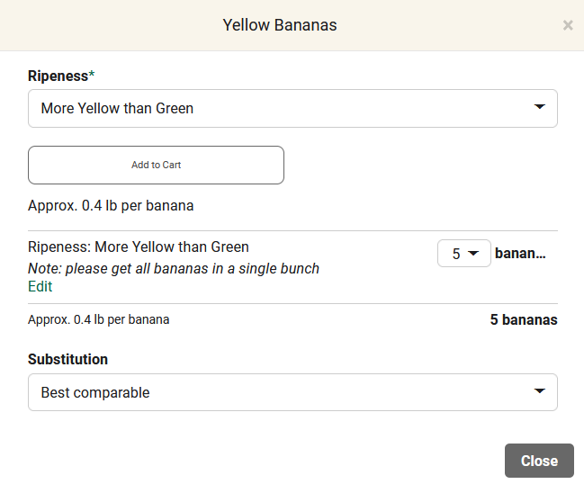

Choose your preferred ripeness from this dropdown menu
Add a note if you have more to say! This note requests that all 5 bananas are in a single bunch
Pay attention to produce quantity, these are sold per banana, not per bunch

What if the Product I Order Isn’t Available?
If a product you ordered is unexpectedly sold out, we’ll still do our best to get what you want!
“Substitutions”

Best Comparable: will 2 regular size products work instead of 1 family size? We’ll contact you to make sure if you’ve chosen this option. You’ll be charged for the substituted product
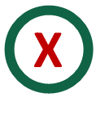
No Substitution: prefer to skip the item if your selection is out of stock? Choose this option and we’ll leave it off your order. You won’t be charged.

Complete Your Order

Choose Your Pickup Time
You can select a pickup a window a few hours from the time you place your order, to give us to the time to pick and bag your items.
[Photo]
If there is extremely high demand, you may see the earliest pickup time being further out than a few hours, based on our availability.

Checking Out
When you are done shopping, click on the shopping cart icon at the top of the page.
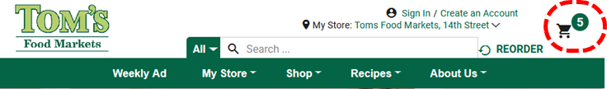
Your full shopping list will be displayed. Here you can change quantities, substitution options, and even add notes to any or all items in your list.
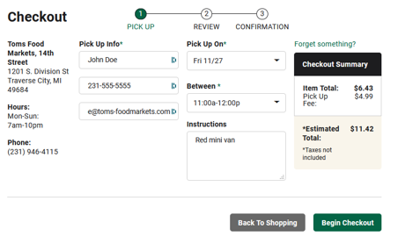
You will be taken to a screen where you will be able to choose your pickup date and time (if you haven’t already), add a phone number, and add instructions.

Once you’re satisfied with your order, click on the ‘Begin Checkout’ button at the bottom of the screen.

The next page will give you one last chance to review your order: your Pickup Details, any Order Notes, the List of Items, a place to apply Promotion Codes, and your Payment info.
Once you enter your credit card information and click the payment button, you will be taken to your order confirmation.
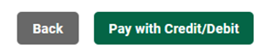
You’ll receive a confirmation of your order, and will also receive a confirmation e-mail to the e-mail address associated with your account.
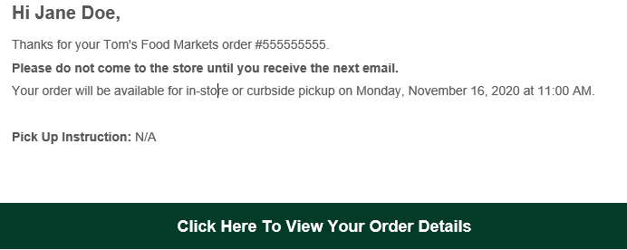

Click this button in your confirmation e-mail to view, modify, or cancel your order.

Come to Tom’sXpress Lane

Where to Go
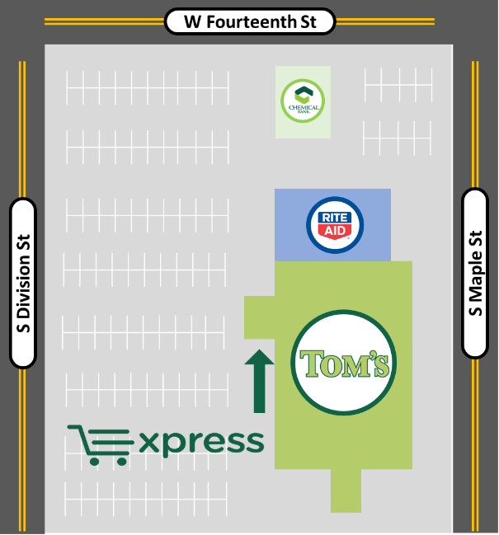
Tom’sXpress Lane is located right at the front of the store, pull your car up to the sign.
An employee will greet you before getting your order, and is available to answer questions.
You can stay in your car, we will load your bags.
This map shows details for the 14th St location located at 1201 S Division Street, follow similar directions at other locations.

